**Bedford County Public Schools K-12 Math Textbook Start up Manual**

**C:\Users\ddrennen\AppData\Local\Microsoft\Windows\Temporary Internet Files\Content.IE5\HXM8TSSY\MC900094733[1].wmf**

**Table of Contents**

I. Creating a New Teacher Account

New teacher accounts must be created for new employees **or** for any teacher that transfers to a different school.

II. Adding Additional Titles/Products to your account

This procedure is used when setting up a new teacher account or adding a different grade level/subject to an existing teacher account. Teachers are not limited to the number of products per account.

III. Creating a Class

IV. Adding Students to Class Roster

V. Adding an Individual Student to Class Roster

This procedure is used when a teacher needs to enter a student that transferred from another district or the student was not in the original district upload.

VI. Print Parent Letter **(This provides student user name and password)**

VII. Transferring Students within the district

**\*\*\*This is the ONLY procedure that must be done at the division level. Contact the Math Supervisor to transfer students within the district.**

**I. Creating a New Teacher Account**

1. Go to [www.pearsonsuccessnet.com](http://www.pearsonsuccessnet.com)

2. Click on Register

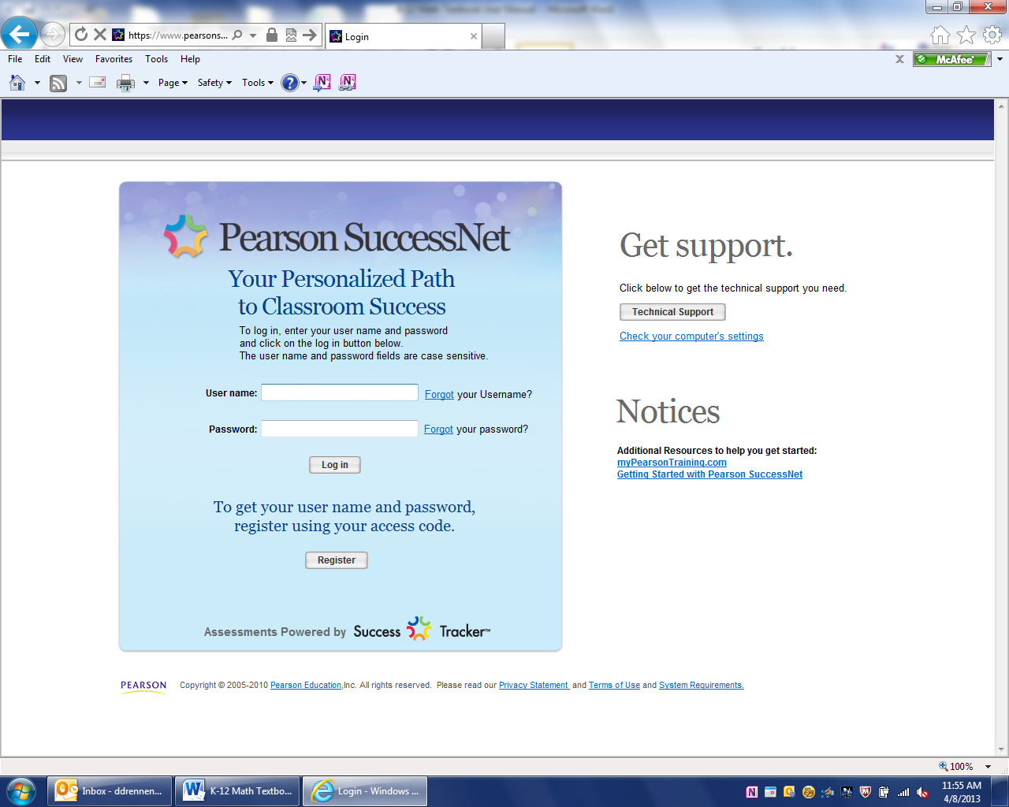

3. Enter access code for your product. **ALL** product codes are located on the last pages of this manual. Only enter one code at this time, you will enter additional codes later.

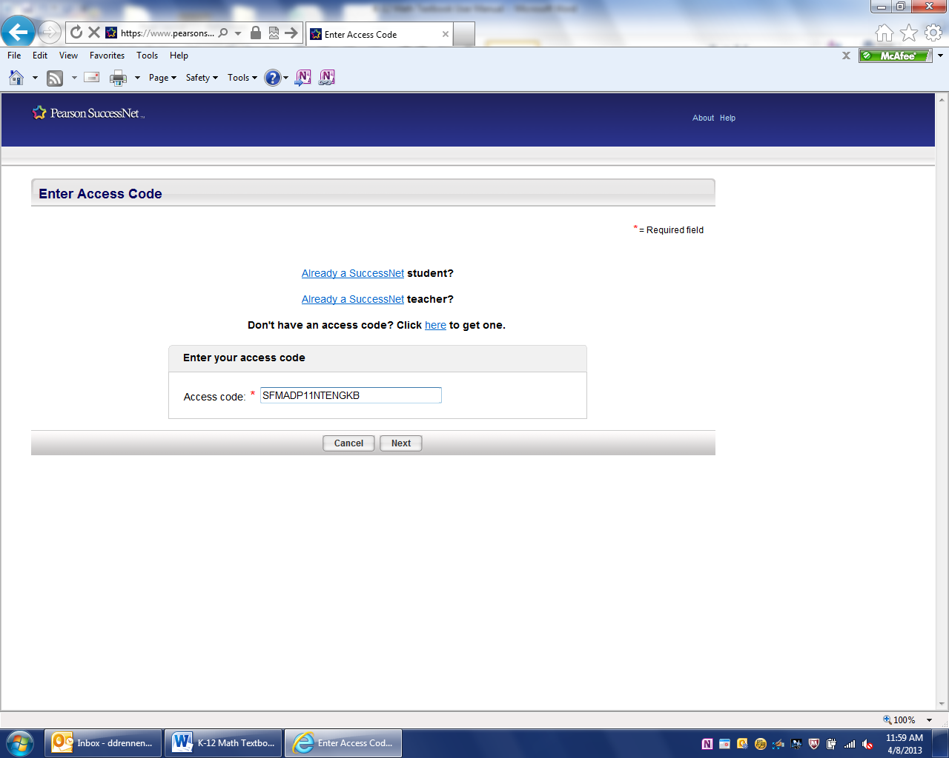

4. Click Next

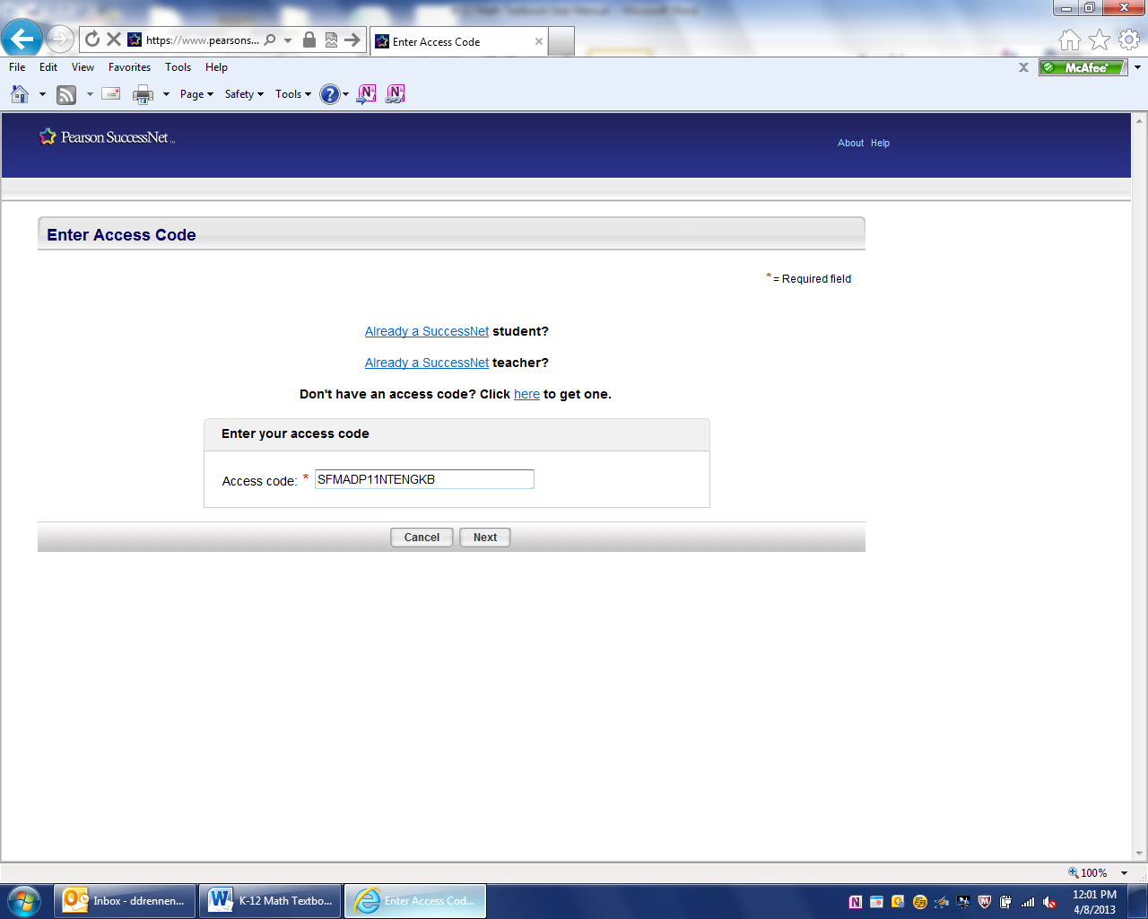

5. Complete the enter profile page. Use you school zip code.

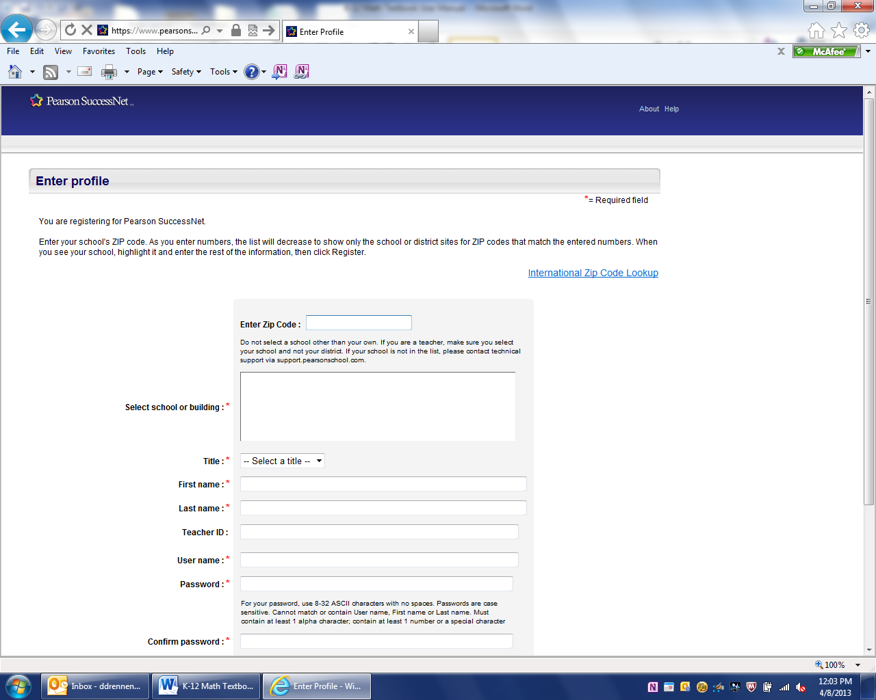

6. Click Register

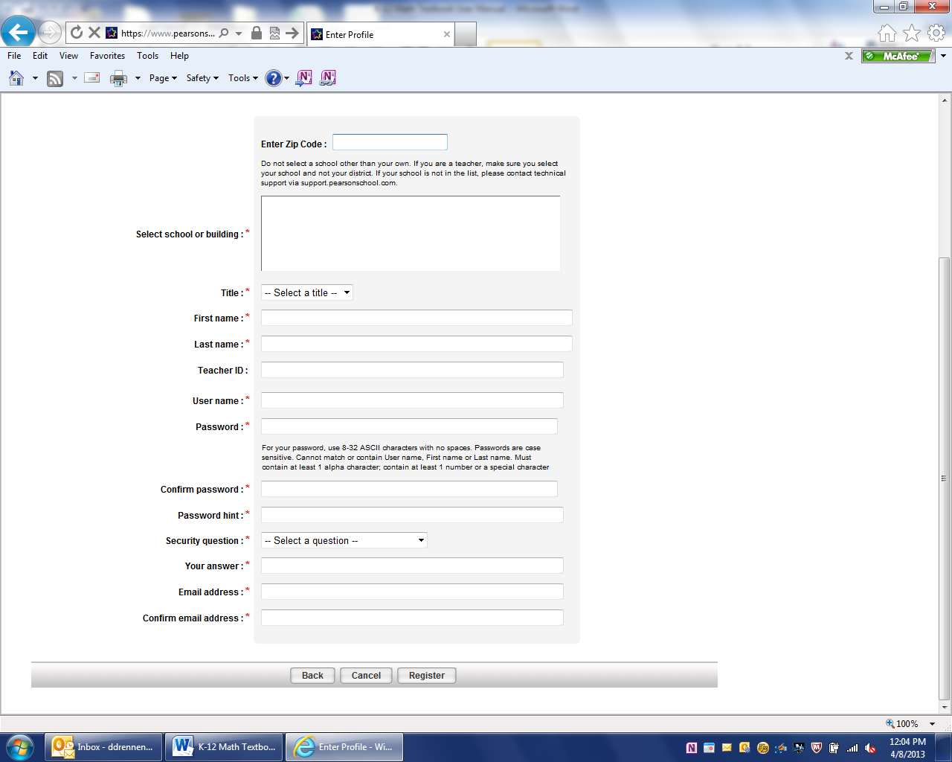

**II. Adding Additional Titles/Products to your account**

1. Go to [www.pearsonsuccessnet.com](http://www.pearsonsuccessnet.com) and login to your home page with your user name and password.

2. Click the drop down arrow next to your name

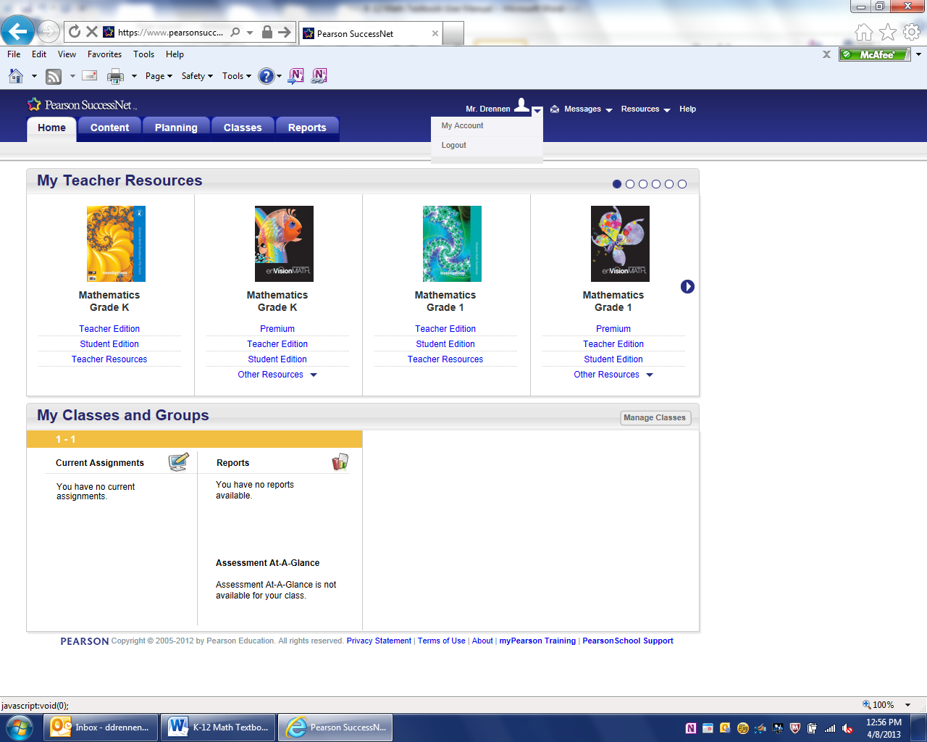

3. Click on My Account



4. On the next Screen Click on Manage Products

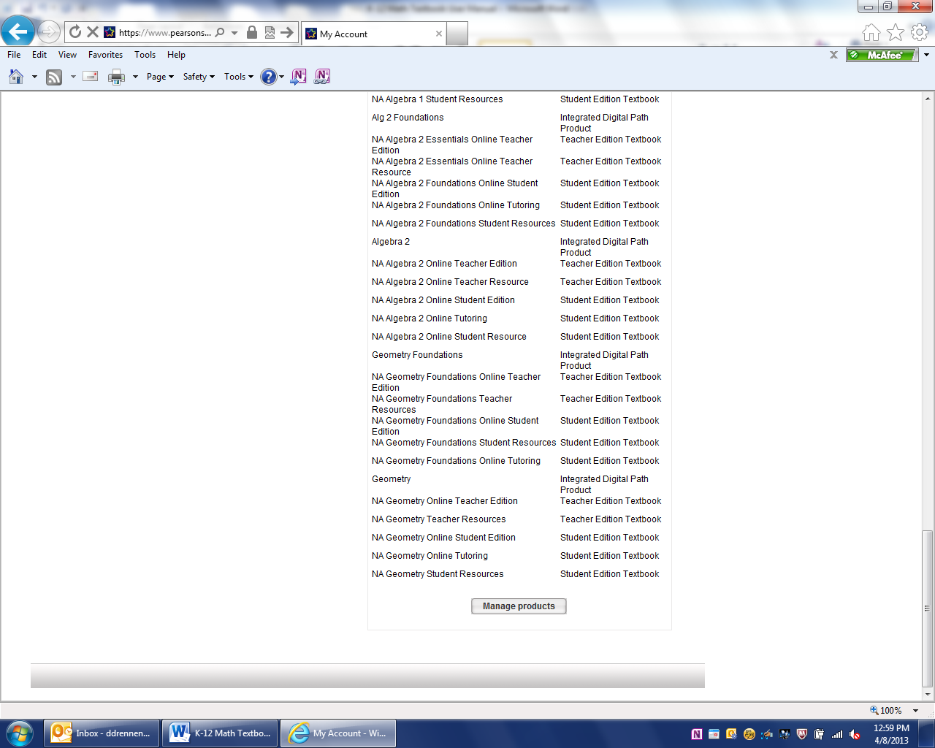

5. Click Add New Products

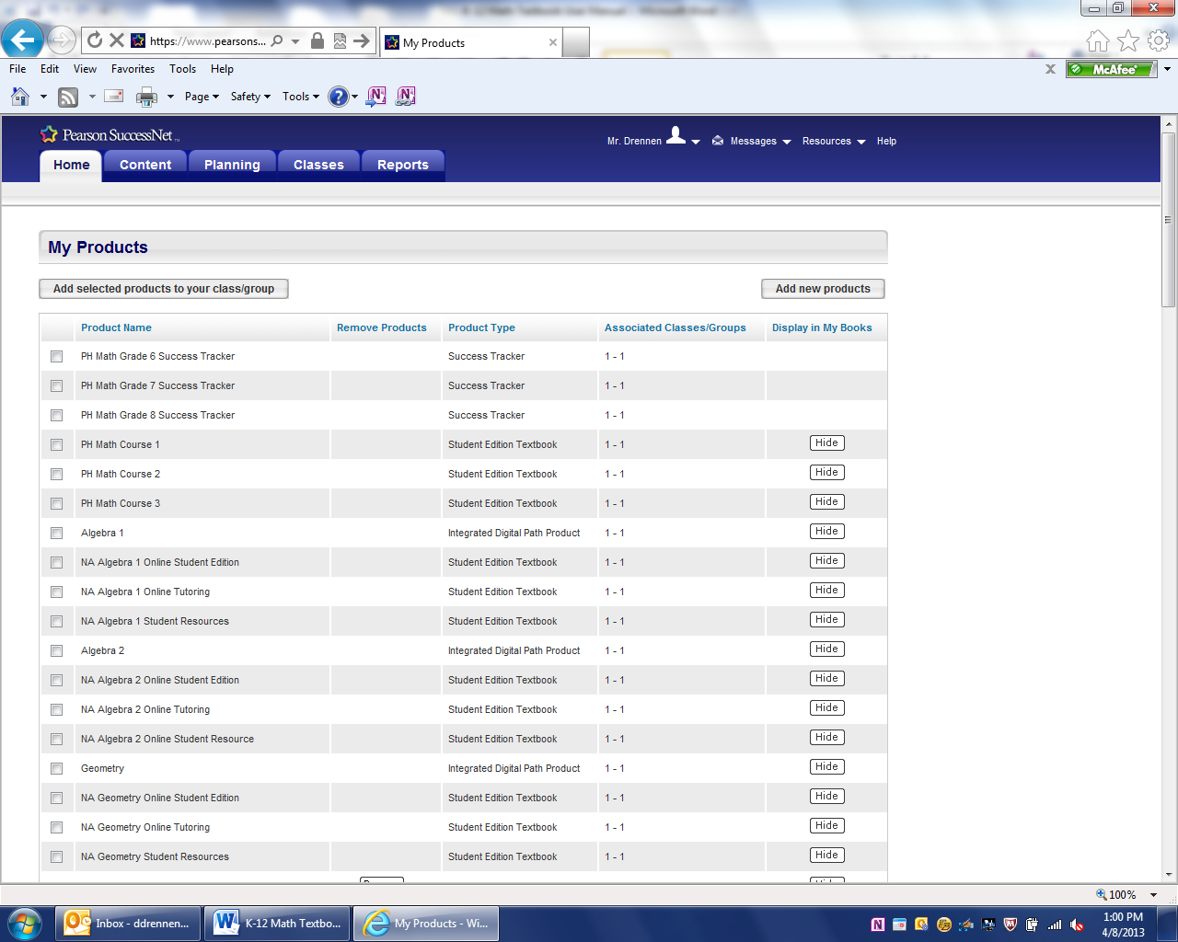

6. Enter Access Code and Click Check Code

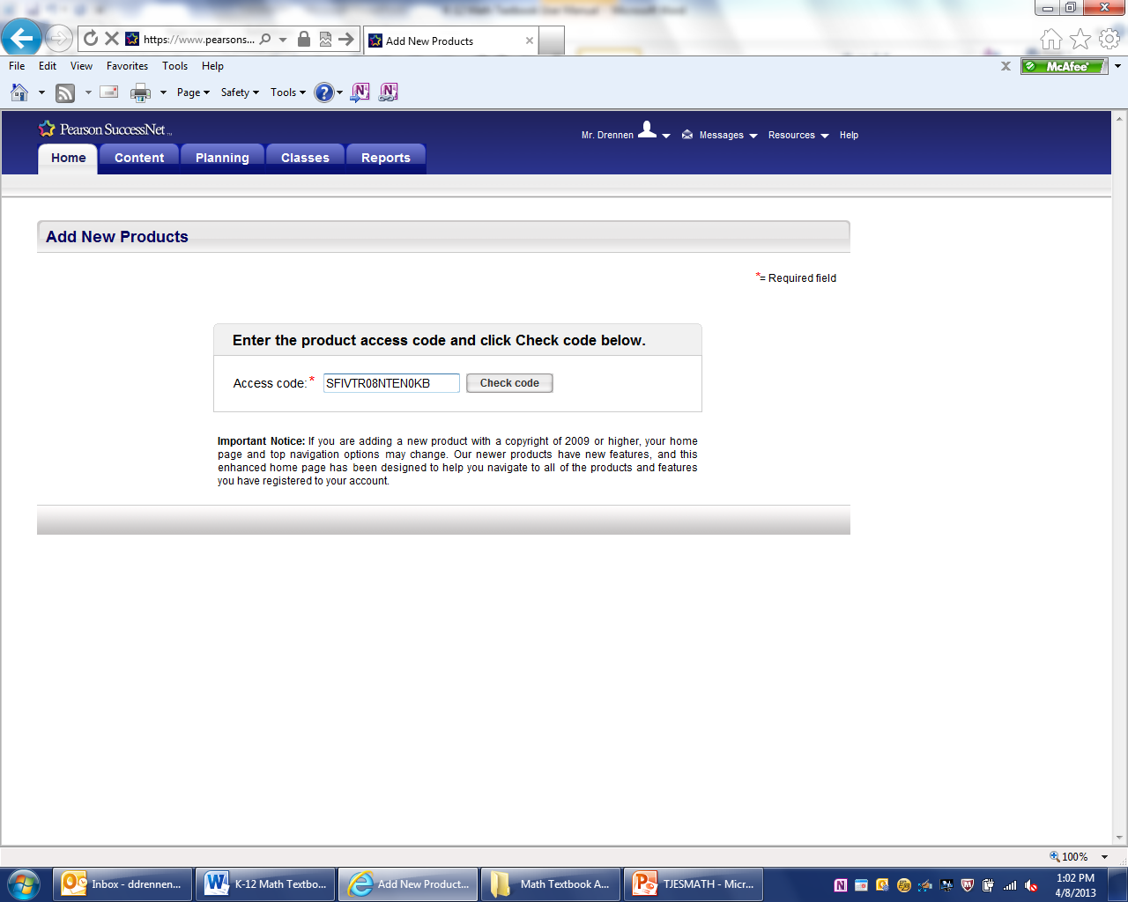

7. Click Save and Repeat Steps 2-6 for additional products

8. Log out and then log in for the products to appear in your account.

**III. Creating a Class**

1. Go to [www.pearsonsuccessnet.com](http://www.pearsonsuccessnet.com) and login to your home page with your user name and password.

2. On your home page click on Classes

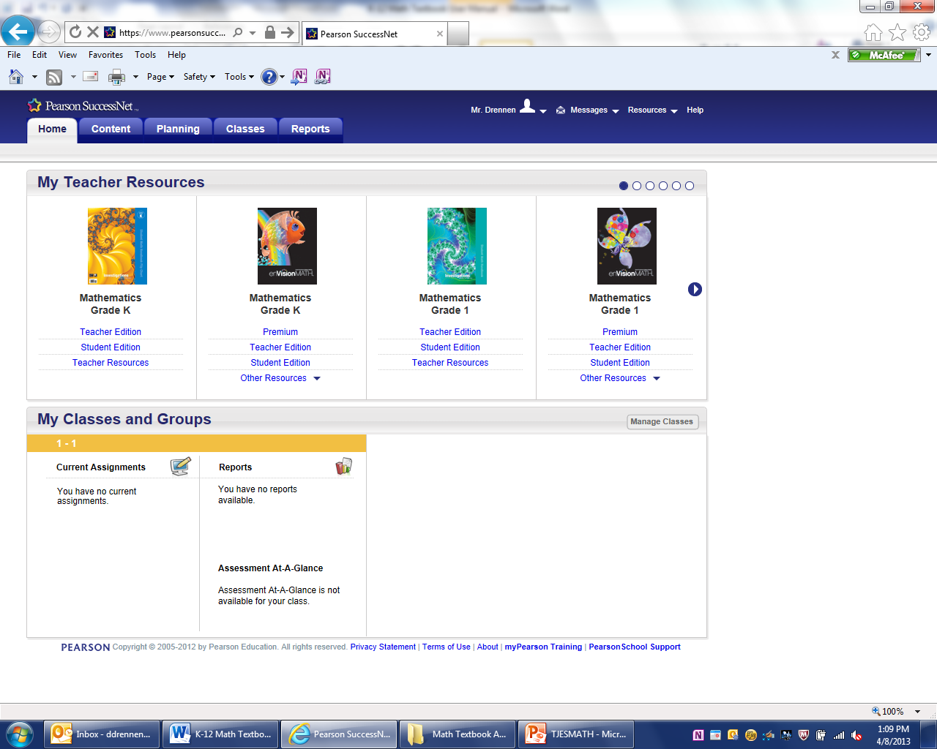

3. Click on Build New Classes

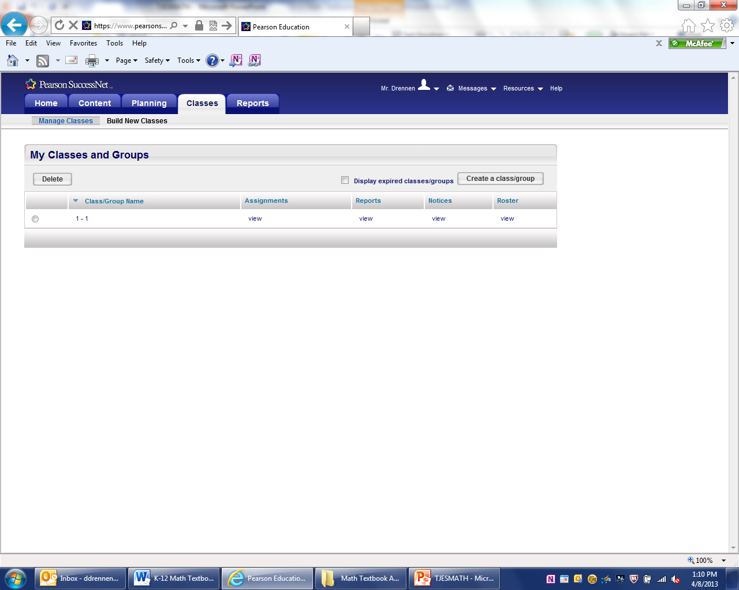

4. Enter in details for red asterisks

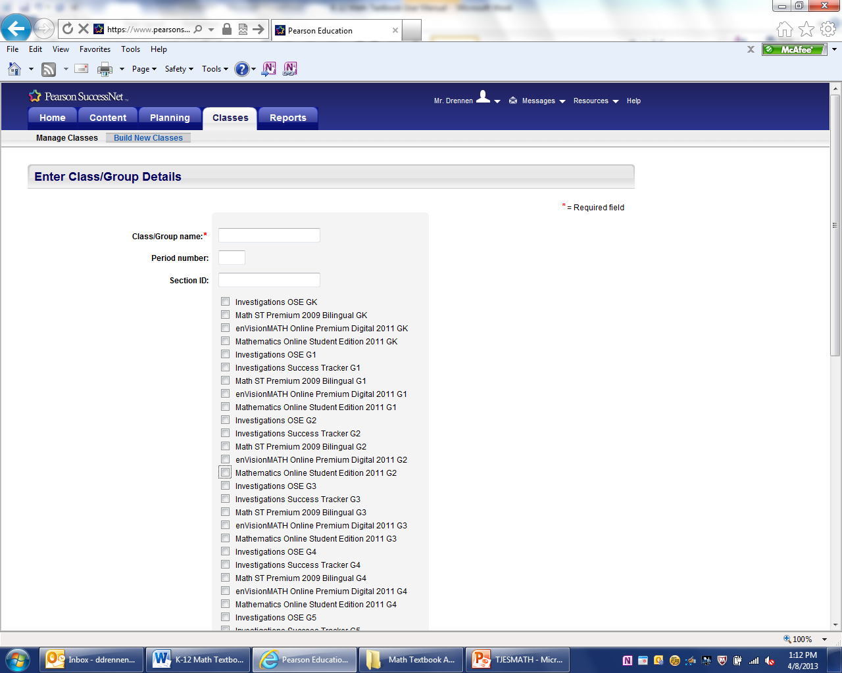

5. Put a check next to items you want students to access.

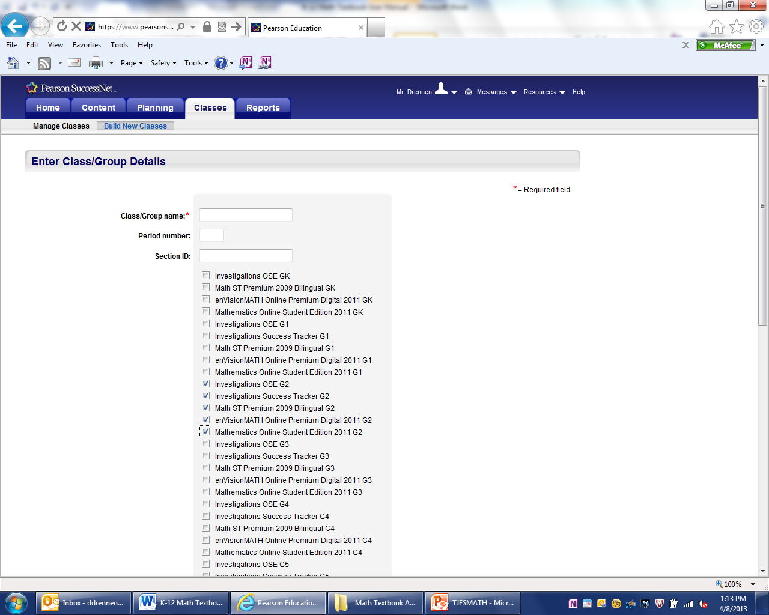

6. Save

7. Repeat Steps 2-6 for additional classes.

**IV. Adding Students To Your Class Roster**

1. Go to [www.pearsonsuccessnet.com](http://www.pearsonsuccessnet.com) and login to your home page with your user name and password.

2. On your home page click on Classes



3. Click on Manage Classes



4. Click View under the Roster Heading for your selected class.



5. Click Select from School Roster

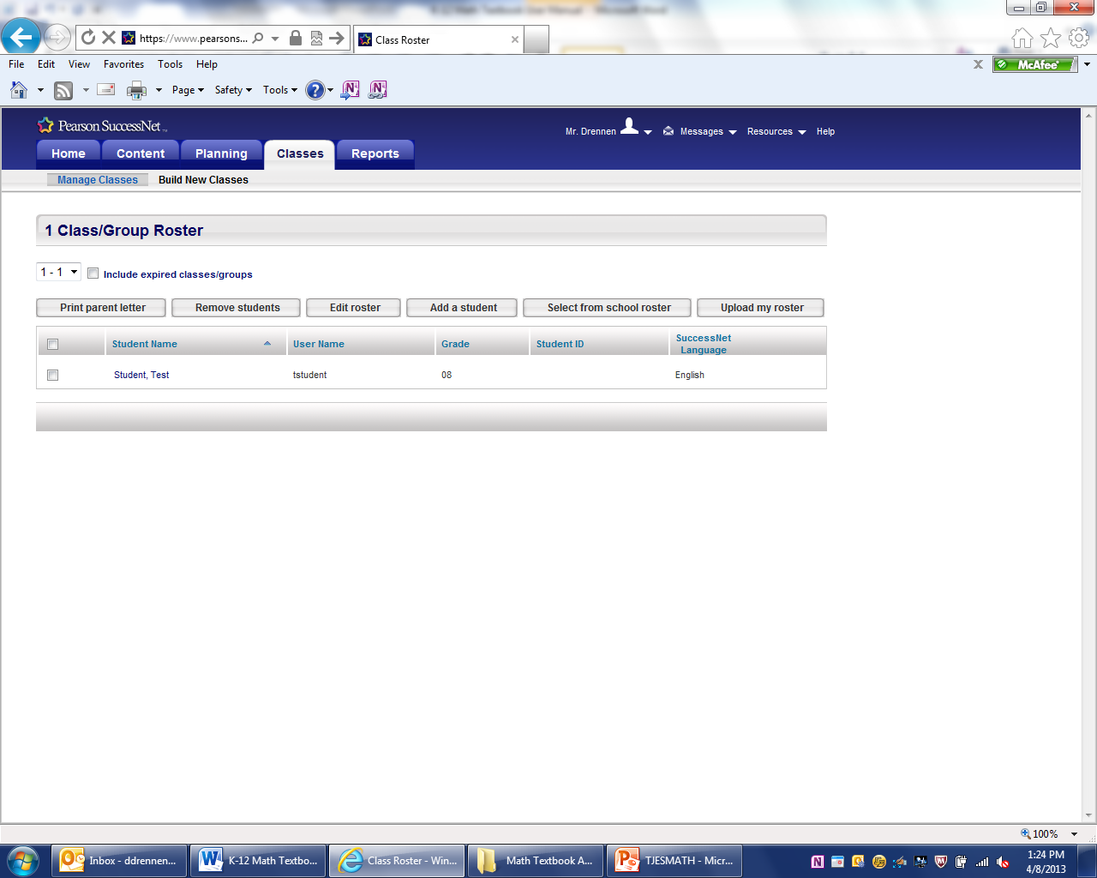

6. Click the box next to all the students in the class

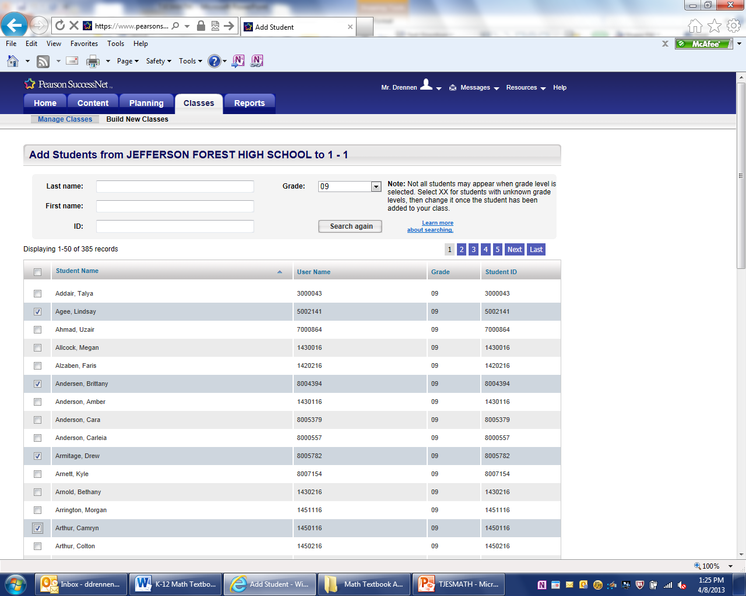

7. Click Save at the bottom of the list when you have selected all of your students

8. Repeat Steps 2-7 for each class.

**V. Adding an Individual Student to Class Roster**

This procedure is used when a teacher needs to enter a student that transferred from another district or the student was not in the original district upload.

1. Go to [www.pearsonsuccessnet.com](http://www.pearsonsuccessnet.com) and login to your home page with your user name and password.

2. On your home page click on Classes



3. Click on Manage Classes



4. Click View under the Roster Heading for your selected class.



5. Click on Add a Student. **Note: A student can be added to multiple math teachers.**



6. Enter Red Asterisk Fields. The user name and password should be formatted similar to other students.

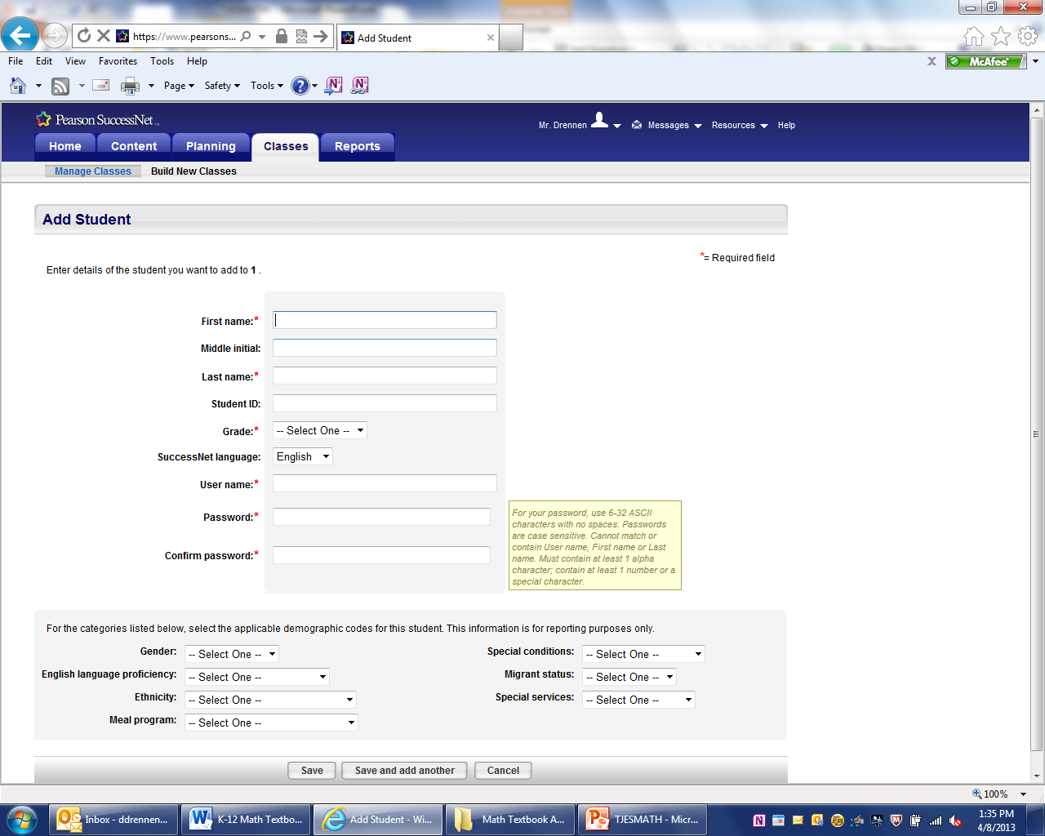

7. Click Save or Save and add another if more students need to be added.



**VI. Print Parent Letter (This provides student user name and password)**

1. Go to [www.pearsonsuccessnet.com](http://www.pearsonsuccessnet.com) and login to your home page with your user name and password.

2. On your home page click on Classes



3. Click on Manage Classes



4. Click View under the Roster Heading for your selected class. 

5. At the roster select ALL students by clicking on the check box next to the Student Name Header. Individual students can be selected by checking the box next to their name.

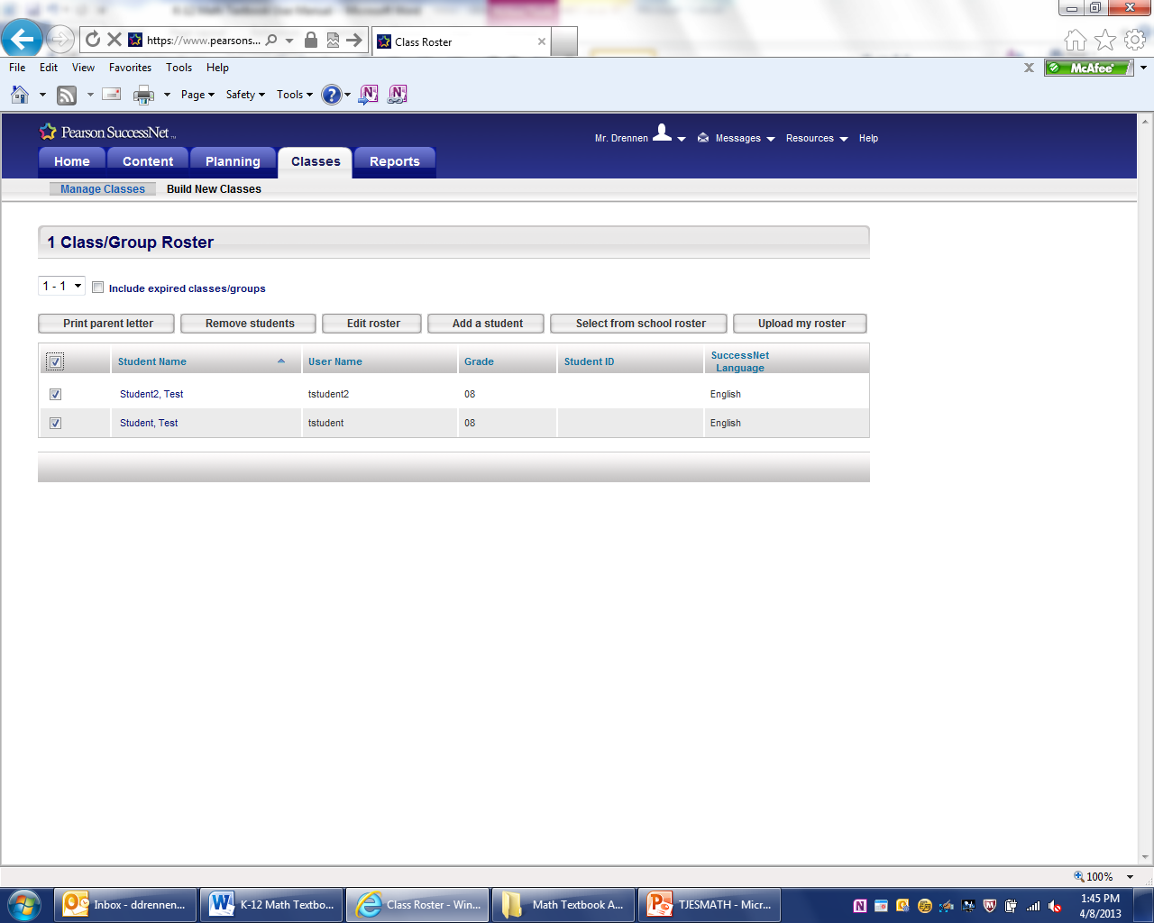

6. Click Print Parent Letter

7. Give out the letters to the students

8. Repeat steps 2-7 for all classes.

**VII. Transferring Students within the district**

**\*\*\*This is the ONLY procedure that must be done at the division level. Contact the Math Supervisor to transfer students within the district.**

**Product Codes**

**enVision Math Online Premium Digital 2011 G?  
Math 2011 Online Teacher Edition Grade ?  
Math 2011 Online Teacher Resource Grade ?  
Math ST Premium 2009 Bilingual G?  
Mathematics Online Student Edition 2011 G?**

|  |  |
| --- | --- |
| **Kindergarten** | SFMADP11NTENGKB |
| **First Grade** | SFMADP11NTENG1B |
| **Second Grade** | SFMADP11NTENG2B |
| **Third Grade** | SFMADP11NTENG3B |
| **Fourth Grade** | SFMADP11NTENG4B |
| **Fifth Grade** | SFMADP11NTENG5B |

**Investigations OTE G?  
Investigations Student Resources**

|  |  |
| --- | --- |
| **Kindergarten** | SFIVTR08NTEN0KB |
| **First Grade** | SFIVTR08NTEN01B |
| **Second Grade** | SFIVTR08NTEN02B |
| **Third Grade** | SFIVTR08NTEN03B |
| **Fourth Grade** | SFIVTR08NTEN04B |
| **Fifth Grade** | SFIVTR08NTEN05B |

**Investigations Success Tracker G?**

|  |  |
| --- | --- |
| **Kindergarten** | No K success tracker  Use the First Grade Code, this includes some Kindergarten SOLs |
| **First Grade** | SFMAST08NTENI1T |
| **Second Grade** | SFMAST08NTENI2T |
| **Third Grade** | SFMAST08NTENI3T |
| **Fourth Grade** | SFMAST08NTENI4T |
| **Fifth Grade** | SFMAST08NTENI5T |

**Investigations OSE G?  
Investigations Student Resources**

|  |  |
| --- | --- |
| **Kindergarten** | SFIVSR08NTEN0KB |
| **First Grade** | SFIVSR08NTEN01B |
| **Second Grade** | SFIVSR08NTEN02B |
| **Third Grade** | SFIVSR08NTEN03B |
| **Fourth Grade** | SFIVSR08NTEN04B |
| **Fifth Grade** | SFIVSR08NTEN05B |

**INV11 INTRCTV WHTBRD ACT GR.?**

|  |  |
| --- | --- |
| **Kindergarten** | SFIVIWB11NTENGK |
| **First Grade** | SFIVIWB11NTENG1 |
| **Second Grade** | SFIVIWB11NTENG2 |
| **Third Grade** | SFIVIWB11NTENG3 |
| **Fourth Grade** | SFIVIWB11NTENG4 |
| **Fifth Grade** | SFIVIWB11NTENG5 |

**Grade 6 Math**

PHMA07NTENC1BT

**Pre-Algebra (Grade 7)**

PHMA07NTENC2TB

**Algebra Concepts (Grade 8)**

PHMA07NTENC3TB

**Algebra 1**

PHMADP11NTENA1B

**Geometry**

PHMADP11NTENGMB

**Algebra 2**

PHMADP11NTENA2B