PowerTeacher Gradebook

Getting Started
About Getting Started
To get started, you must log in to PowerTeacher and then launch gradebook.

Log In to PowerTeacher
Before you can log in to PowerTeacher, you will need your school's PowerTeacher URL, your username, and your password.

http://powerschool.bedford.k12.va.us/teachers

Note: Do not use someone else’s password or give your password to anyone else.
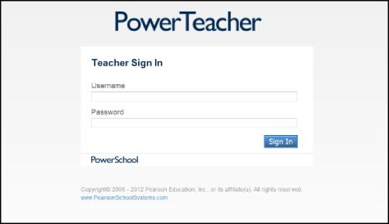
How to Log In to PowerTeacher

- Open your web browser to your school's PowerTeacher URL. The Log In page appears.
- Enter your username in the first field.
- Enter your password in the second field.

Note: The characters appear as asterisks (*) to ensure greater security when you log in.

- Click Sign In. The PowerTeacher start page appears.

Launching PowerTeacher Gradebook
Once you have logged in to PowerTeacher, you can then launch gradebook from the PowerTeacher start page.

Note: If you experience a loss of connection, please check your network connection or contact your system administrator.

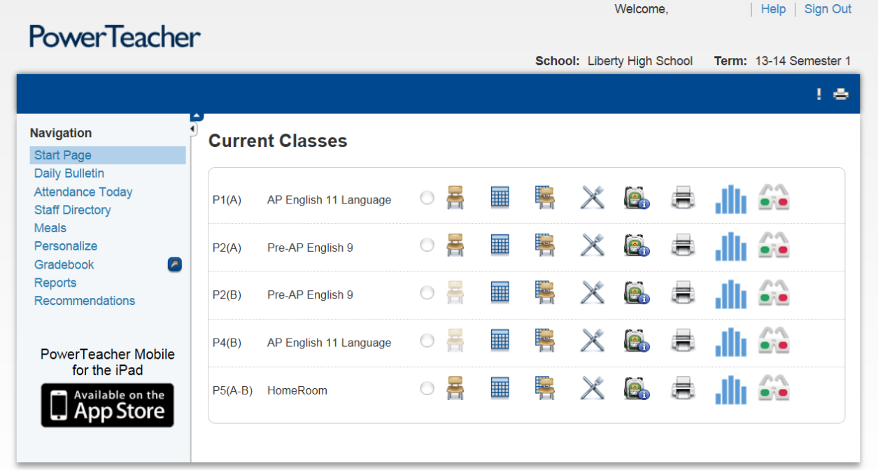

How to Launch PowerTeacher Gradebook for Windows

- Click Gradebook. The PowerTeacher Gradebook Launch page appears.
- Click Gradebook. The File Download window appears, accompanied by the Warning Security window. Click Always trust content from the publisher checkbox.
- Click Run. The Java Web Start and Gradebook version windows briefly appear. Then, PowerTeacher gradebook opens.

Note: You may only have one active session of PowerTeacher gradebook launched at a time. If you attempt to launch a second session of PowerTeacher gradebook, the Terminate Other Sessions window appears, stating "Other active sessions exist for this user account. Would you like to terminate the other sessions or quit this session?" Either click Terminate Other Sessions or Quit.

- Close the Downloads window.

Verify Password
If your session has timed out, you may be asked to re-enter your password to continue working.

How to Verify Password
1. On the Verify Password window, enter your password.
2. Click OK.

Main PowerTeacher Gradebook Window
When you launch PowerTeacher gradebook, the main PowerTeacher Gradebook window appears. This window serves as the central point from which you begin your gradebook session.

The PowerTeacher Gradebook window consists of the following main areas:
- ID Bar
- Menu Bar
- Navigation Bar
- Classes
- Student Groups
- Categories

The PowerTeacher Gradebook window has four panes, which are adjustable, both horizontally and vertically. To adjust the width of a pane, click and hold the vertical three-line icon and drag right or left. To adjust the height of a pane, click and hold the horizontal three-line icon and drag up and down.
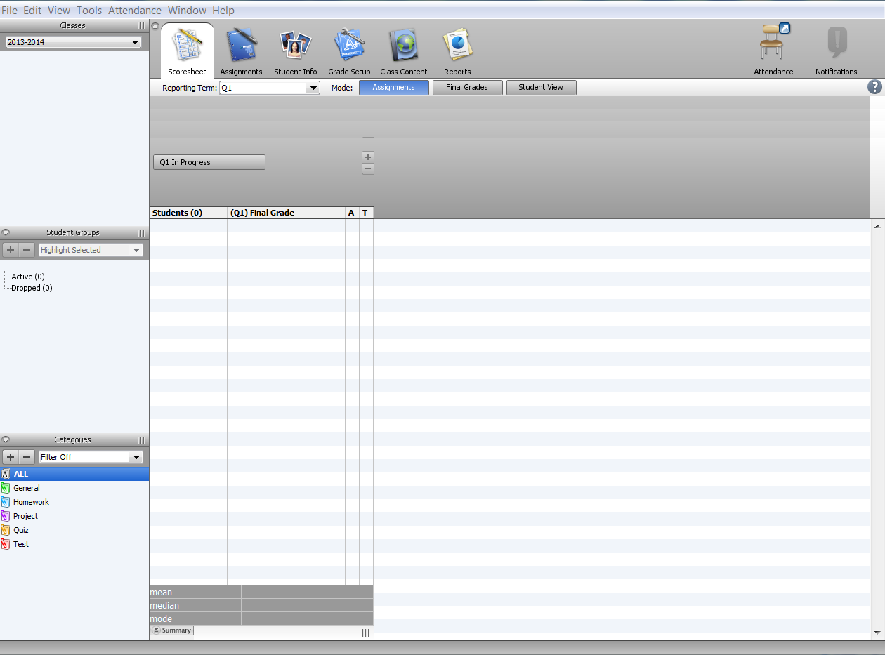
Menu Bar
Navigation Bar

Classes

Student List
Student Groups

Categories

Menu Bar
The menu bar appears at the top of your display and provides access to the following menus:

Feature | Description
File | Use the dropdown menu to select one of the following commands:  - Save  - Revert – reverts to unsaved changes  - Refresh Class Info  - Lock Gradebook  - Exit
Edit | Use the dropdown menu to select one of the following commands:  - Cut  - Copy  - Paste
View | Use the dropdown menu to select one of the following commands:  - Scoresheet  - Assignments  - Students Info  - Grade Setup  - Class Info  - Reports  - Zoom
Tools | Use the dropdown menu to select one of the following commands:  - Check Spelling  - Categories  - Score Inspector  - Fill Scores  - Import Scores  - Recalculate Final Scores  - Copy Assignment  - Export Scores Template  - Email Students and Parents  - Birthdays  - Copy Final Grade Setup  - Preferences
Window | Use the dropdown menu to choose New Window to open another instance of the gradebook so that you can access other areas of the gradebook at on time.
Help | Use the dropdown menu to choose one of the following commands:  - Content to launch online help. Choose Quick Entry Tips to view keyboard shortcuts.  - Choose What Every Teacher Should Know to view valuable tips on using PowerTeacher gradebook.  Note: The PowerTeacher gradebook help window is also accessible by clicking the Help icon, which looks like a question mark.

ID Bar
The ID bar appears at the top of the PowerTeacher Gradebook window and displays your name and the name of your school.

Classes
The Classes pane appears in the upper-left corner of the PowerTeacher Gradebook window and includes the Term Selector and Class List.

Student Groups
The Student Groups pane appears in the lower-left corner of the PowerTeacher Gradebook window and displays student groups for a selected class.

Navigation Bar
The navigation bar appears at the top of the PowerTeacher Gradebook window and provides a quick way to access the following areas:

Feature | Description
Scoresheet | Click this tab to access the Scoresheet window  - Assignments mode  - Final Grades mode  - Student View mode
Assignments | Click this tab to access the Assignments window
Students Info | Click this tab to access the Students window
Grade Setup | Click this tab to access the Grade Setup window  - Calculations  - Grading Scales
Class Content | Click this tab to access the Class Content window  - Class Info  - School Content  - My Content
Reports | Click this tab to access the Reports window

Classes
About Classes
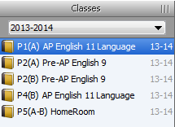
The Classes pane appears in the upper-left corner of the PowerTeacher Gradebook window and includes the Term Selector and Class List. The Term Selector dropdown menu displays terms within the current full year term. The Class List displays classes for the selected term.

Select Terms
When you first launch PowerTeacher gradebook, the current term displays. To select a different term, choose a term from the Term Selector dropdown menu.

Select Classes
When you first launch PowerTeacher gradebook, the Class List displays classes for the current term. The first class in your daily schedule appears highlighted. For each class, the periods/days, course name, and full year term appear. Note that the Scoresheet window appears as the default window. To select a different class, select a class from the Classes pane. The window in which you were last working refreshes for the selected class.

View Class Information
To view information about a particular class, select the class and click the Class Content tab.

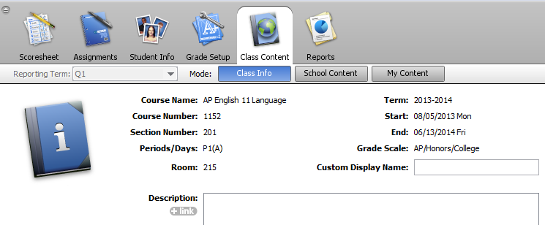
How to View Class Information

- Select a class from the Classes pane.
- Click the Class Content tab. The Class Information window displays basic information about the class in the Class Info mode.

Note: The Description field will be used to display information on the PowerSchool Parent Portal.

Students Info
About Students
The Students window displays a list of students enrolled in a class and basic information about each student.

View Students
To view students for a particular class, select the class and click the Students tab.

- Select a class from the Classes pane.
- Click the Students tab. The Students window displays the class roster, which includes basic information for each student. Click on the arrow next to the students name or double click on the student name to display basic information, if not displayed.

View Alerts
A student may have one or more of the following alerts: Discipline, Guardian, Medical, or Other. If an alert icon appears for a student, click to view the specific text for the alert. All alerts indicate information for the student that administrators want to bring to the teacher’s attention.

- Select a class from the Classes pane.
- Click the Students tab. The Students window appears.
- Double click the student's name or click the arrow next to the student's name. The Student tab appears at the bottom of the Students window.
- Click the Discipline, Guardian, Medical, or Other icon to view the alert text. The Alert window appears.
- Click OK to close the Alert window.
Student Groups
About Student Groups
Students arrive on the first day of school with different needs and levels of readiness. Using student groups, you can adapt instruction to the particular needs of students.
Student groups are made up of a hierarchical structure; a set, groups within that set, and students within those groups. Student groups are class-specific. Therefore, you will need to create student groups for each class in which you want to use student groups.

Reports
In order to generate reports for a specific set, group, individual student, selection of students, or any combination, you will need to set up student groups. Simply create a set, a group, and add students to the group. Then, on any report, select the Selected Group(s) and/or Students option and then select the set, group, individual student, selection of students, or any combination from the Students Group pane that you want in the report.
For example, if you need to generate a report for a remedial group within a selected class, you can create a group for those students. Create a set called Remedial or Intervention, and then create a group indentifying students with the same needs. Drag students from the student list into the new group.

Create Sets
The first step to creating student groups is to create a set. Remember that the class for which you are creating student groups must be selected. Once you have created the sets you want, you can then create groups for those sets.
You can create sets using the Plus (+) button. Alternately, you can right-mouse click on the Active group under Student Groups.
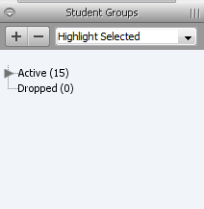
- Select a class from the Classes pane.
- In the Student Groups pane, click the Plus (+) button and choose Add Group Set. An Add Student Group Set window will open; enter a name for the set.
- Enter the title of the group in the Group Set Name textbox.
- Click Ok to save your changes.
- A new group will appear in the Student Group pane with a subgroup default Group 1 with zero students in it.

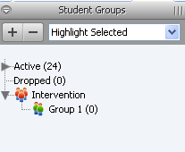
- To rename Group 1, right click on the name, select Edit. An Edit Student Group dialog box opens. Change the name of the group and click Ok.
- Drag and drop students from students from the students list into the new group.
- To delete a group, select the group; click on the Minus (-) next to the Filter dropdown in the Student Groups pane.

Assignment Categories

About Categories
Before you can create assignments, you must set up categories. Categories are groups of the same types of assignments. Categories are not class-specific, eliminating the need to create the same categories multiple times for each class. By default, PowerTeacher gradebook includes four pre-defined categories, Homework, Project, Quiz, and Test.

Include in Final Grade
When setting up categories, you can use the Include in Final Grade checkbox to indicate whether assignments within a category should be included in calculating final grades. The value set for a category is used as a default for all assignments within that category, but may be overridden on an assignment-by-assignment basis.

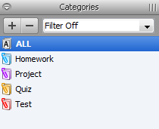
View Categories
The Categories pane appears in the lower-left corner of the PowerTeacher Gradebook window.

Add Categories
Use the Categories window to create assignment categories.

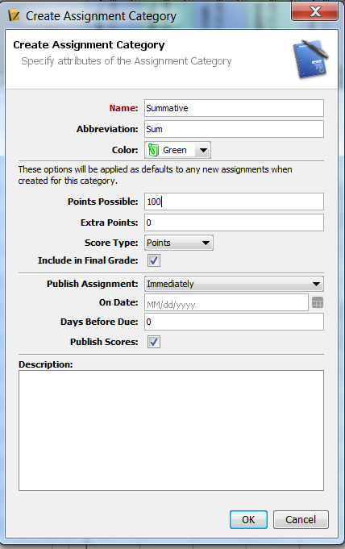
- Click on the Plus (+) button next to Filter Off dropdown box or open the new category window from the gradebook menu bar, choose Tools > Categories. The Create Assignment Category window opens.
- When the new category, Enter the required information.
- Click Ok to save your changes. The Create Assignment Category window closes.

Note: Create Summative and Formative categories. Choose an Abbreviation and Color code. Assign the Points Possible = 100, Extra Points, and the Score Type. Make sure the Include in Final Grade checkbox is selected.

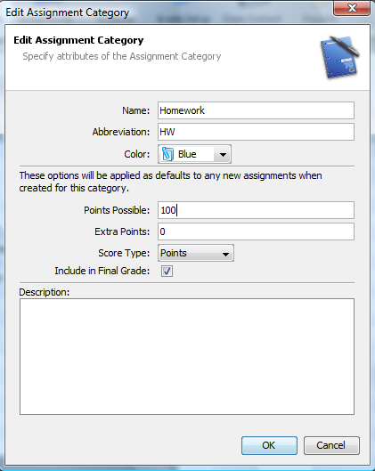
Edit Categories
You can edit a category from the Categories pane.

- Double-click on the category to be edited.
- The Edit Assignment Category window opens.
- Edit the information as needed.
- Click Close to save your changes.

Note: Edit the Homework category. Edit the Points Possible = 100, Extra Points, and the Score Type. Make sure the Include in Final Grade checkbox is selected. Edit any categories that you will not be using but CANNOT delete by changing their name. Example: change General to xGeneral that will move it to the bottom of the list of categories.

Delete Categories
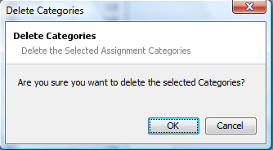
You can delete a category from the Categories pane.

- Select the category to be deleted.
- Click the Minus (-) button next to Filter dropdown box.
- The Delete Categories warning box will open – click Ok to delete the category.

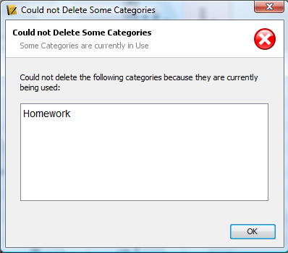
If category has assignments or is used in weighting, the Alert window appears, stating "Could not Delete Some Categories."

- Click OK to close the window.
- In order to delete the category, change the category associated with that assignment and/or remove the weighting.
- Then repeat steps to delete the category.

Note: Delete the categories that will not be used [Test, Quiz, and Project]

Assignments
About Assignments
You can create one assignment at a time as you progress through the term, or you can set up assignments for the entire term before the term starts. Having all assignments for the term before the term starts does not change how grades appear. The Final Grade that appears on the Scoresheet reflects an average grade for only the assignment scores that have been entered.

Before setting up an assignment, consider how you will score the assignment:
- Do you want to record the score as points, a percentage, or letter grade?
- How many points is the assignment worth?
- How do you want to weight the assignment?
- Do you want to include the assignment in final grade calculation?

Include in Final Grade
When setting up assignments, you can use the Include in Final Grade checkbox to indicate whether an assignment should be included in calculating final grades. The value set for a category is used as a default for all assignments within that category, but may be overridden on an assignment-by-assignment basis.
If an assignment is included in calculating final grades and impacts the final grade, it must be published in order for parents and students to view it.

Weighting
Assignment setup may involve weighting; however, weighting is not required. Weighting gives particular assignments, whether points, percentage, or letter grades, more value than others when determining final grades. The weight value is used to multiply the points earned and the points possible.

Add Assignments
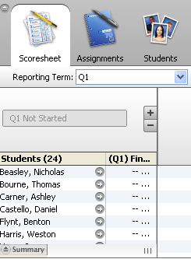
You can add assignments from the Assignments window or the Scoresheet window using the Plus (+) button. Alternately, you can right-mouse click if you are using a two-button mouse.

- MAKE SURE THE CORRECT TERM HAS BEEN SELECTED.
- Select a class from the Classes pane.
- On the Scoresheet window, click the Plus (+) button above the student list. The New Assignment window appears at the bottom of the window (see graphic below).
- Enter the required information.
- Click Save.

Note: The Standards tab is new for those grade level and classes that standards have been entered. Check the checkbox to associate the standard to the assignment.

View All Assignments in a List

  - Select a class from the Classes pane.
  - Double-click on the assignment, basic information about the assignment will appear below the student list or click the Assignments tab. The Assignment window displays class assignments and basic information about each assignment.

Copy Assignments
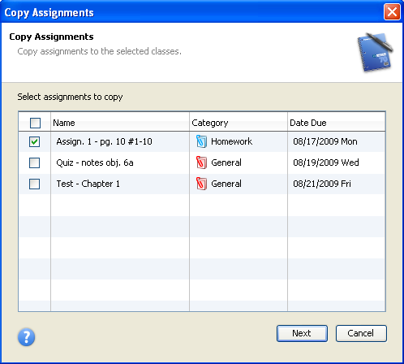
You can use the Copy Assignment function to copy an assignment within a class or from one class to other classes. You can copy assignments from the Assignments window or the Scoresheet window using the gradebook menu bar or right-click on the assignment that is to be copies.

- Select a class from the Classes pane.
- Either choose Tools > Copy Assignment from the gradebook menu bar or right-click on the assignment to be copied and select Copy Assignment.
- The Copy Assignment window opens.
- Select the assignment(s) to be copied and click Next.
- Select the classes the assignment(s) is to be copied into. Click Ok.

Delete Assignments

- Select a class from the Classes pane.
- Select the assignment to be deleted by clicking on it.
- Click on the Minus (-) button next to the list of assignments. A Delete Assignment dialog box will open, click the Yes button.

Grade Setup
Final Grades
Using a combination of options, you can control how Final Grades are calculated in your classes. Grade Preferences apply to ALL of your classes while Grade Setup applies to a SPECIFIC class and must be set up within each class.

Grade Setup
Use final grade setup to specify how final grades will be calculated for students in EACH class.

Final Grades and Categories
When setting up categories, you can use the Include in Final Grade checkbox indicate whether assignments within a category should be included in calculating final grades.

Final Grades and Assignments
When setting up assignments, you can use the Include in Final Grade checkbox indicate whether assignments should be included in calculating final grades.

Note: The value set within an assignment overrides the value for the category the assignment belongs to.

Weighting
Final grade setup may involve weighting; however, weighting is not required. Weighting gives particular assignments, categories, or terms more value than others when determining final grades. The weight value is used to multiply the points earned and the points possible.

Define Grade Preferences
Use the Preferences window to define how you want final grades to appear in PowerTeacher gradebook for ALL classes, either rounded or truncated. You can also indicate the number of decimal places you want to appear.
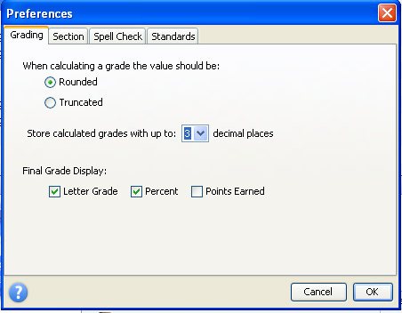
  - From the gradebook menu bar, choose Tools > Preferences. The Preferences window opens.
  - To indicate how you want final grades to be calculated, select the appropriate When calculating a grade the value should be option:
- Rounded: Rounds the number up or down to the nearest decimal point specified.
- Truncated: Cuts off the number at the specified number of places after the decimal.
- Choose the number of digits to appear after the decimal point from the Store calculated grades with up to pop-up menu.
- Select the Final Grade Display checkbox for how your grade will be displayed.
- Click OK to save your changes.

Grade Scales
PowerTeacher gradebook uses a default grade scale that is set up and managed by your school's district administrators. The grading scale is assigned to the course and can not be changed. You can view detailed information about the default grade scale or you can view the grade scale for a specific class.

Calculating Final Grades – Setting up Reporting Terms
Total points method calculates final grades based on how many points a student has accumulated over the term divided by total points possible.

Term weight method calculates final grades based on the total points times the value (or weight) of each term.

Category weight method calculates final grades based on total points times the value (or weight) of each category or assignment.

Calculating Final Grades
- Select a class from the Classes pane.
- Click the Grade Setup tab. The Grade Setup window appears.
- Click on the name of the reporting term you want to set up final grade calculations for.

Note: Calculating Final Grade Using options are based on the selected reporting term. You WILL NEED to complete this set up for EACH CLASS and EVERY REPORTING TERM.

- Select the following for each reporting term:
  - Calculate Y1 (Year) final grade using Term Weights
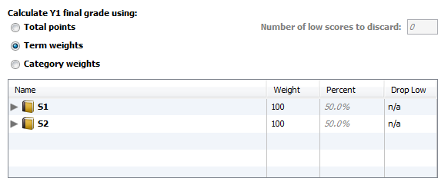

Note: The weight for S1 and S2 can be S1 = 50 and S2 = 50. As long as these two weights are the same, year calculations will be correct.

  - Calculate S1 (First Semester) and S2 (Second Semester) final grade using Term Weights.

Note: Click in the Weight column for each term and change the weight as follows: Q1 = 45, Q2 = 45, E1 = 10.

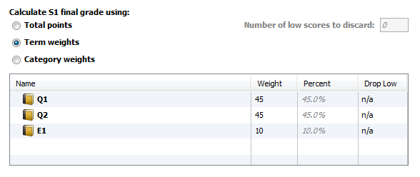

  - Calculate Q1 (First Nine Weeks), Q2 (Second Nine Weeks), Q3 (Third Nine Weeks), and Q4 (Fourth Nine Weeks) final grade using Category Weights.

Note: Click the add category plus (+) sign to add Summative and Formative. Add Homework if you are using it as a category. Change the Weight as follows: Summative = 70, Formative = 30 (if Homework is a category, Formative = 20 and Homework = 10).

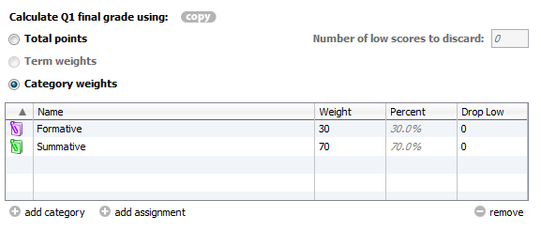

Remember: You MUST set up EACH CLASS for EVERY TERM.

Scoresheets
About Scoresheets
The Scoresheet window is where you will probably spend most of your time. Using the Scoresheet window, you can create and score assignments and view final grades for students in your classes.

View Scoresheets
To view assignments and scores for a particular class, select the class and click the Scoresheet tab.

- Select a class from the Classes pane.
- Click the Scoresheet tab. The Scoresheet window displays basic score information.

Enter Scores Using Scoresheet
You can enter scores from the Scoresheet window or the Score Inspector.

- Select a class from the Classes pane.
- Click the Scoresheet tab. The Scoresheet window appears.
- Click the assignment column of the student you want to enter a score for. The score field appears as an editable text field.
- Enter the score.
- Press ENTER. The score appears on the Scoresheet and the cursor advances to the next assignment field.
- Click Save. The score appears on the Scoresheet window.

Note: The Save and Revert buttons appear shaded until information is entered.

Edit Scores Using Scoresheet
You can edit a score from the Scoresheet window or the Score Inspector.

- Select a class from the Classes pane.
- Click the Scoresheet tab. The Scoresheet window appears.
- Click the score you want to edit. The score field appears as an editable text field.
- Enter the new score.
- Press ENTER. The new score appears on the Scoresheet and the cursor advances to the next assignment field.
- Click Save. The new score appears on the Scoresheet window.

Note: The Save and Revert buttons appear shaded until information is entered.

Delete Scores Using Scoresheet
You can delete a score from the Scoresheet window or the Score Inspector.

- Select a class from the Classes pane.
- Click the Scoresheet tab. The Scoresheet window appears.
- Click the score you want to delete. The score field appears as an editable text field.
- Do one of the following:
- Highlight the score and press DELETE.
- Right-click and select Clear Score.

Note: There are no restrictions when deleting.

- Press ENTER. The score no longer appears on the Scoresheet and the cursor advances to the next assignment field.

Mark Assignments Collected Using Scoresheet
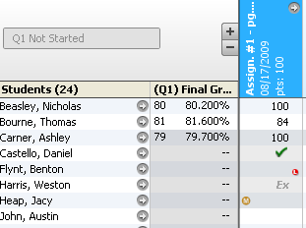
To indicate that an assignment for a student has been collected, mark the assignment as Collected from the Scoresheet window or the Score Inspector. An assignment can be marked as collected with or without entering a score. If no score is entered, a green checkmark appears within the selected student assignment score field. If a score is entered, the checkmark is replaced with the score.

- Select a class from the Classes pane.
- Click the Scoresheet tab. The Scoresheet window appears.
- Click in the assignment column of the student whose assignment has been collected.
- Right-click and select Collected.
- Click Save. The score appears on the Scoresheet window.

Note: The Save and Revert buttons appear shaded until information is entered.

Mark Assignments Late Using Scoresheet
To indicate that an assignment for a student is late, mark the assignment as Late from the Scoresheet window or the Score Inspector. An assignment can be marked as late with or without entering a score. When marked as late, a red circular “L” appears within the selected student assignment score field.
- Select a class from the Classes pane.
- Click the Scoresheet tab. The Scoresheet window appears.
- Click in the assignment column of the student whose assignment is late.
- Right-click and select Late.
- Click Save. The score appears on the Scoresheet window.

Note: The Save and Revert buttons appear shaded until information is entered.

Mark Assignments Exempt Using Scoresheet
To indicate that an assignment for a student is exempt, mark the assignment as Exempt from the Scoresheet window or the Score Inspector. An assignment can be marked as exempt with or without entering a score. If a score has been entered, the score will appear grey and will not be calculated in the average. If no score is entered, an italicized “Ex” appears within the selected student assignment score field. If a score is entered, the score appears italicized and shaded.

- Select a class from the Classes pane.
- Click the Scoresheet tab. The Scoresheet window appears.
- Click in the assignment column of the student who you wish to exempt from the assignment.
- Right-click and select Exempt.

Note: You may also manually enter ex in the assignment score field.

- Click Save. The score appears on the Scoresheet window.

Note: The Save and Revert buttons appear shaded until information is entered.

Mark Assignments Missing Using Scoresheet
To indicate that an assignment for a student is missing, mark the assignment as Missing from the Scoresheet window or the Score Inspector. When marked as missing, a yellow circular “M” appears within the selected student assignment score field.
- Select a class from the Classes pane.
- Click the Scoresheet tab. The Scoresheet window appears.
- Click in the assignment column of the student whose assignment is late.
- Right-click and select Missing.
- Click Save. The score appears on the Scoresheet window.

Note: The Save and Revert buttons appear shaded until information is entered.

View Assignment Statistics
The Summary section of the Scoresheet provides statistical information for each assignment. When selecting an assignment, the mean, median, and mode for that assignment appear.

The mean is the mathematical average of the scores you entered. The median represents the middle of all values: one-half of the scores will be above this number and one-half will be below it. The mode indicates the most common value.

All of these values are indicators of how well your students did on the assignment. If any one of them is unexpectedly low, it may be that students need additional practice on the skills and concepts being assessed, or the assessment needs to be revised.

- Select a class from the Classes pane.
- Click the Scoresheet tab. The Scoresheet window appears.
- Select an assignment.
- Click Summary. The mean, median, and mode appear for the selected assignment.

The Points Earned appears in the lower-right corner of the Scoresheet. When a final grade or assignment is selected, the total points earned to date appear.
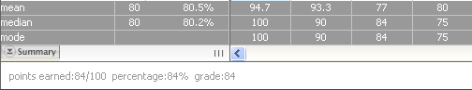

Fill Scores
Use the Fill Scores command to quickly and easily enter the same score for all students or for only those with unrecorded scores. For example, if all but two students in a class receive the same assignment score, use the Fill Scores function to enter that score for the class with the exception of the scores already entered for the two students.

You can fill scores from the gradebook menu bar or right-click on the assignment column.
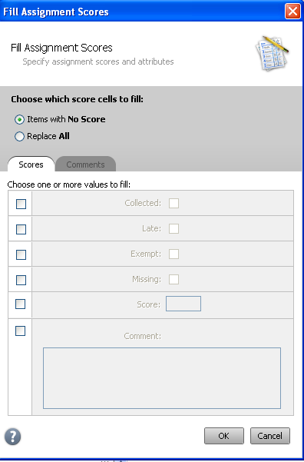
- Select a class from the Classes pane.
- Click the Scoresheet tab. The Scoresheet window appears.
- Select the assignment column for which you want to fill scores.
- From the gradebook menu bar, choose Tools > Fill Scores or right-click on the assignment column. The Fill Scores window appears.
- Indicate whether you want to only fill Items with No Score or Replace All.
- To indicate the assignment status, select one of the following:
- Collected
- Late
- Exempt Score
- Missing
- Enter the score in the Score field.
- Manually enter score comments in the Comment field and/or click Comment tab to select one or more predefined comments.

Note: If using the Comment tab, you can press and hold CONTROL to select multiple comments. When you have finished making your selections click the Insert Selected button.

- Click OK.

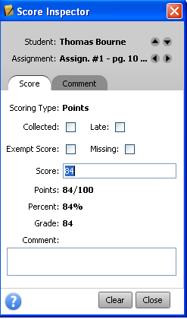
Score Inspector
The Score Inspector provides an alternative way of entering scores and other information. Once you open the Score Inspector window, it floats above the Scoresheet window. You may want to move it to a convenient location on your desktop, so you can work with the Scoresheet. The Score Inspector remains open until you choose to close it.

You can open the Score Inspector from the gradebook menu bar or the Scoresheet window.

- Select a class from the Classes pane.
- Click the Scoresheet tab. The Scoresheet window appears.
- Do one of the following:
- From the gradebook menu bar, choose Tools > Score Inspector. The Score Inspector window appears.
- From any assignment field (or Final Grade field) within the Scoresheet, right-click and select Score Inspector.
- The Score Inspector window appears.
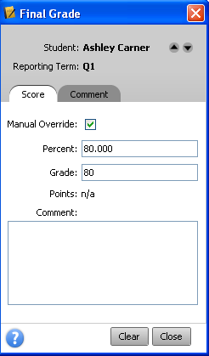
View Final Grade Details
You can view final grade details from the Score Inspector window.
- Select a class from the Classes pane.
- Click the Scoresheet tab. The Scoresheet window appears.
- Click on the Final Grades mode button.
- Open the Score Inspector. The Score Inspector window appears.

The final grade details appear in the Score Inspector window.

Note: This is where the final grade can be manually overridden. Click on the Manual Override checkbox and enter the new grade.

Add Score Comments

- Select a class from the Classes pane.
- Click the Scoresheet tab. The Scoresheet window appears.
- Open the Score Inspector. The Score Inspector window appears.
- Select the assignment of the student you want to update. The assignment details appear in the Score Inspector window.
- Manually enter score comments in the Comment field and/or click Comment tab to select one or more predefined comments.

Note: If using the Comment tab, you can press and hold CONTROL to select multiple comments. When you have finished making your selections, click the Insert Selected button.

- Use the Previous and Next arrows to repeat for each student, if applicable.
- Click Close on the Score Inspector and Save on the Scoresheet window. A blue circular “C” appears within the selected student assignment score field.

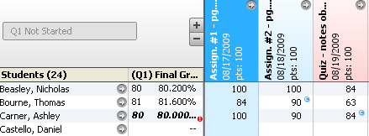

Add Final Grade Comments

- Select a class from the Classes pane.
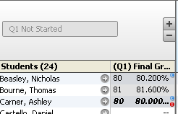
- Click the Scoresheet tab. The Scoresheet window appears.
- Open the Score Inspector. The Score Inspector window appears.
- Select the final grade of the student you want to update. The final grade details appear in the Score Inspector window.
- Manually enter final grade comments in the Comment field and/or click Comment tab to select one or more predefined comments.

Note: If using the Comment tab, you can press and hold CONTROL to select multiple comments. When you have finished making your selections, click the Insert Selected button.

- Use the Previous and Next arrows to repeat for each student, if applicable.
- Click Close on the Score Inspector and Save on the Scoresheet window. A blue circular “C” appears within the selected student final grade field.

Fill Final Grade Comment

- Select a class from the Classes pane.
- Click the Scoresheet tab. The Scoresheet window appears.
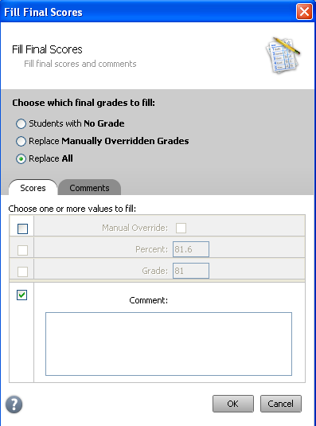
- From the gradebook menu bar, choose Tools > Fill Scores or right-click a student average in the Final Grade column and choose Fill Scores. The Fill Final Scores window appears.
- Select the Replace All radio button and check the Comment checkbox.
- Manually enter final grade comments in the Comment field and/or click Comment tab to select one or more predefined comments.

Note: If using the Comment tab, you can press and hold CONTROL to select multiple comments. When you have finished making your selections, click Insert Selected button.

- Click Ok on the Fill Final Scores window and Save on the Scoresheet window. A blue circular “C” appears within the selected student final grade field.

Note: When manually entering a final grade comment, limit comment length.

Reports
About Reports
You can print various reports whenever you want without having to wait for your PowerSchool or school administrator to do it for you. PowerTeacher gradebook offers a selection of reports to assist you in daily classroom activities, as well as with assessing student performance. Using the Reports tab in the navigation bar, you can generate reports for all students who are enrolled in a class, for all students who are enrolled in all your classes, or for a specific set, group, individual student, selection of students, or any combination.

Run the Attendance Grid Report
Run the Attendance Grid report to generate a student and date grid for taking attendance.

- Select a class from the Classes pane.
- Click the Reports tab. The Reports window appears.
- Double-click Attendance Grid report. The Attendance Grid window appears.
- To use the default report settings, skip to Step 5. Otherwise, enter the required information.
- Click Run Report. The Report Complete window appears.
- Select one of the following options:
  - Open Report
  - Save Report – if you choose to save the report you will be asked for a save location. Reports are saved as pdf files.
- Click OK.

Sample Report
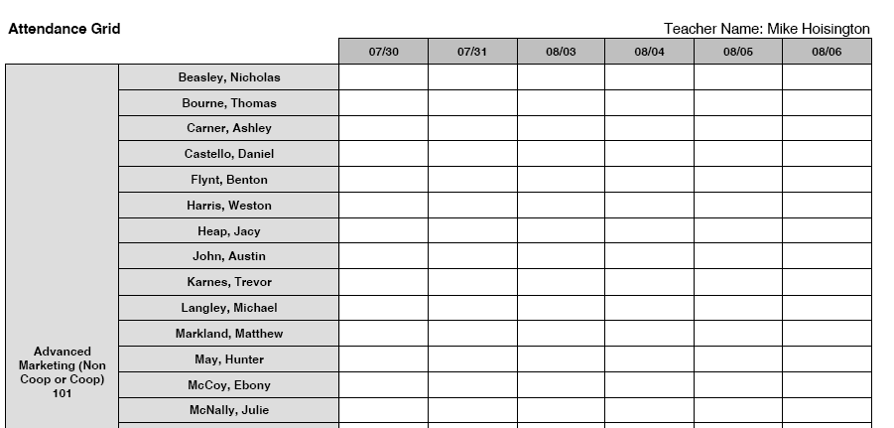

Run the Final Grade and Comment Verification Report
Run the Final Grade and Comment Verification report to generate a list of final grades and comments by reporting term.

- Select a class from the Classes pane.
- Click the Reports tab. The Reports window appears.
- Click Final Grade and Comment Verification report. The Final Grade and Comment Verification window appears.
- To use the default report settings, skip to Step 5. Otherwise, enter the required information.
- Click Run Report. The Report Complete window appears.
- Select one of the following options:
  - Open Report
  - Save Report – if you choose to save the report you will be asked for a save location. Reports are saved as pdf files.
- Click OK.

Sample Report
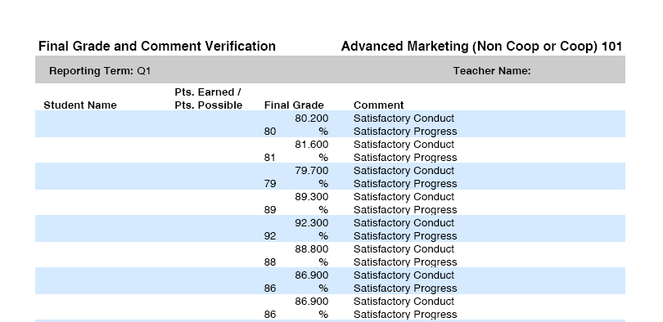

Run the Individual Student Report
Run the Individual Student report to generate a summary of class activity on a student-by-student basis.

- Select a class from the Classes pane.
- Click the Reports tab. The Reports window appears.
- Click Individual Student Report. The Individual Student Report window appears.
- To use the default report settings, skip to Step 5. Otherwise, enter the required information.
- Click Run Report. The Report Complete window appears.
- Select one of the following options:
  - Open Report
  - Save Report – if you choose to save the report you will be asked for a save location. Reports are saved as pdf files.
- Click OK.

Sample Report
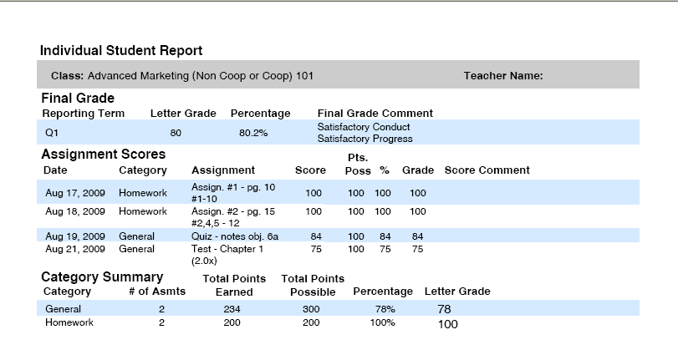

Run the Missing Assignment Report
Run the Missing Assignments report to generate a list of assignments that have not been scored.

- Select a class from the Classes pane.
- Click the Reports tab. The Reports window appears.
- Click Missing Assignment report. The Missing Assignment window appears.
- To use the default report settings, skip to Step 5. Otherwise, enter the required information.
- Click Run Report. The Report Complete window appears.
- Select one of the following options:
  - Open Report
  - Save Report – if you choose to save the report you will be asked for a save location. Reports are saved as pdf files.
- Click OK.

Run the Scoresheet Report
Run the Scoresheet report to generate a spreadsheet-style summary of student grade and assignment date.

- Select a class from the Classes pane.
- Click the Reports tab. The Reports window appears.
- Click Scoresheet report. The Scoresheet report window appears.
- To use the default report settings, skip to Step 5. Otherwise, enter the required information.
- Click Run Report. The Report Complete window appears.
- Select one of the following options:
  - Open Report
  - Save Report – if you choose to save the report you will be asked for a save location. Reports are saved as pdf files.
- Click OK.

Run the Student Roster Report
Run the Student Roster report to generate a summary of student demographic information on a student-by-student basis.

- Select a class from the Classes pane.
- Click the Reports tab. The Reports window appears.
- Click Student Roster. The Student Roster window appears.
- To use the default report settings, skip to Step 5. Otherwise, enter the required information.
- Click Run Report. The Report Complete window appears.
- Select one of the following options:
  - Open Report
  - Save Report – if you choose to save the report you will be asked for a save location. Reports are saved as pdf files.
- Click OK.

