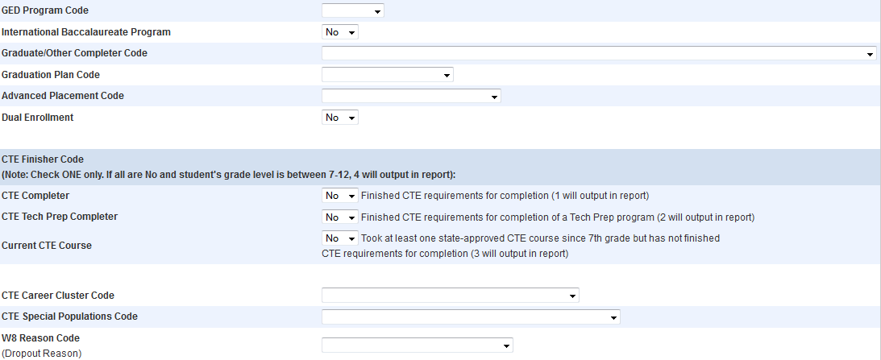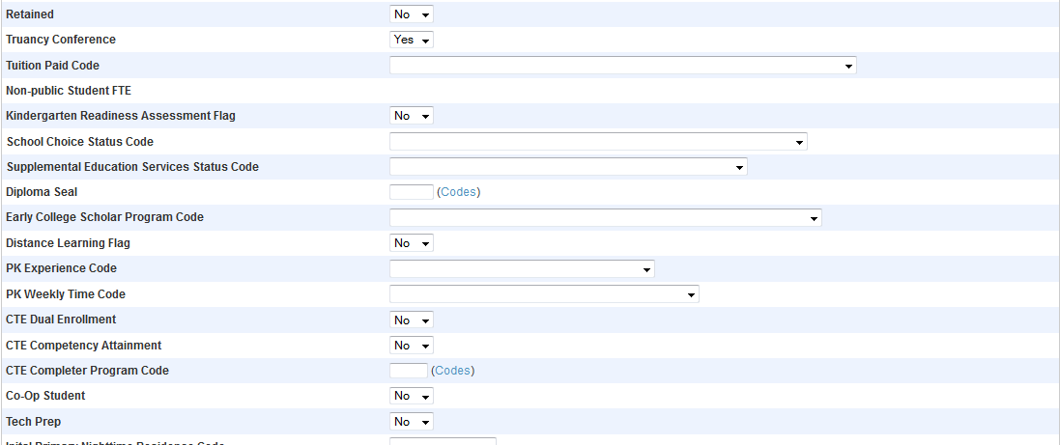

EOY PowerSchool Tagging
Orange Area
Retained – Needs to be set to Yes if the student is not graduating or not being moved up to the next grade level on June 8th. You will also need to change the next grade on the Scheduling Setup page. Even if the student only needs to attend summer school to complete their work, they still need to be marked as retained. Remember this report is a snapshot of a point in time. Also if the student is retained the graduation completer code must be blank as well as the Graduation Plan code for those students in grade 12.

Red Areas
GED Program codes – Needs to be set to ISAEP if student is under the age of 18 and enrolled in the section taught by Amy Sell at LHS (BSTC). Also the Graduation Completer Code must be set to GED through ISAEP.

Graduate/Other Completer Code – needs to be set for all students that are graduating or completing school. ONLY FOR STUDENT GRADUATION OR COMPLETING SCHOOL! If the student is Sped and coming back please mark retained.

Graduation Plan Code – ALL STUDENTS MARKED AS A GRADUATE OR COMPLETER MUST HAVE A GRADUATION PLAN CODE. This gets over looked every year. This is crucial for reports having to deal with post graduate plans.

Advanced Placement Code – needs to be marked appropriately for any student that has taken or is taking an AP course.

Dual Enrollment - needs to be marked appropriately for any student that has taken or is taking a dual enrollment course.

Diploma Seals – Needs to have the appropriate seal assigned to the student. Click on codes to see the list of codes.

Early College Scholars Code – this field is so overlooked and it shows. This field is what tells the DOE to generate a certificate to those graduates that have completed the Governor’s Early College Scholars Agreement, or completed the program, or completed the Commonwealth’s Scholars program, or participated in both, or completed both. This needs to be filled out for every student that has signed the agreement or is participating in the programs. Then on the March 30th report it needs to be changed for all graduates or completers that has completed the programs and should get the certificate.

Distance Learning Flag - needs to be marked appropriately for any student that has taken or is taking a distance learning course.

Green Areas – CTE
CTE Completer – Set field to Yes if the student is a CTE Completer

CTE Tech Prep Completer – Set field to Yes if the student is a CTE Tech Prep Completer. This would only apply to BSTC completers in dual enrollment courses.

Current CTE Course – Set field to Yes if the student has ever taken a CTE course since 7th grade. I cannot make the field default to Yes.

CTE Career Cluster Code – Select the appropriate Career Cluster Code for which the student is enrolled. See Dr. Connor chart.

CTE Special Populations Code – We only have used Non-Traditional. Please mark appropriately for the student that is considered a non-traditional gender for the CTE program. Se Dr. Connor chart.

CTE Dual Enrollment - needs to be marked appropriately for any student that has taken or is taking a dual enrollment CTE course.

CTE Competency Attainment - needs to be marked appropriately for any student that has achieved the competency for the CTE courses which they completed.

CTE Completer Program Code – needs to be completed for any Graduate that has completed the CTE course work and completed the program. Please see Dr. Connor’s chart for the completer program codes.

Tech Prep - needs to be marked appropriately for any student that has taken or is taking a dual enrollment CTE course.

